**Loyalty Management System**



**Developed by:**

Syed Toqeer Abbas 013

**Supervised by:**

Rashid Ismail

**NCBA & E (lcu Campus)**

**Declaration**

I am hereby to declare that this software neither as a whole nor as a part thereof has been copied out from any source. It is further declared that we developed this software and this report entirely on the basis of my personal effort made under the sincere guidance of my project supervisor.

If any part of this software is proved to be copied or found to be a report of some other, we shall standby the consequences.

No portion of the work presented in this report has been submitted in support of any application for any other degree or qualification of this or any other university or institute of learning.

I understand and transfer copyrights for these materials to NCBA&E.

I shall not sale this software and documents and shall not get any financial gains from these.

**Students Signature**

Syed Toqeer Abbas _____________________

**Project Supervisor Signature**

Rashid Ismail _____________________

**Final Approval**

This is to certificate that we have read the project report submitted by the students.

Syed Toqeer Abbas

In our judgment this report is of sufficient standards to warrant its acceptance by NCBA&E for BS (IT) degree.

**Examination Committee**

**Internal Supervisor:** Rashid Ismail

**Designation:** Project Coordinator

**Study center:** NCBA&E

**Internal Examiner:** _____________________

**Designation:** _____________________

**Study Center:** _____________________

**External Examiner:** _____________________

**Designation:** _____________________

**Acknowledgement**

I am humbly prostrate to Allah the almighty, the most benevolent and the most merciful for showering his blessing on us throughout our lives and especially during our final project of BS (IT). It was he and the prayers of our parents, who gave me courage and will to complete this project.

I owe a debt of sincere gratitude, heartiest obligation and appreciation to our worthy teacher **Rashid Ismail**. For their guidance, insightful comments and valuable suggestions.

I am thankful to my beloved parents and all of who prayed for my success and time and again restored our confidence ourselves and help us in every possible way they could.

I want to pay my heartiest tribute to my seniors, all friends for their consistent encouragement, cooperation, inspiring guidance about the project. They helped me in times of troubles; their love, support, devotion and sincerity have been admiration.

**Syed Toqeer Abbas**

**Project In Brief**

**Project Title:** Loyalty Management System

**Organization:** Global TekSoft

**Objectives:** Manage Customers relations and engaged him with company.

**Developed by:** Syed Toqeer Abbas

**Supervised By:** Rashid Ismail

**Tools used:** Visual Studio, Xampp

**Operating System:** Windows 10

**System Used:** Core i5

**Abstract**

**(One Page Summary of the Project)**

**Need**

Loyalty programs came into existence when companies realized that the competitive advantage that they once experienced due to product differentiation no longer holds good due to a proliferation of similar looking and “me too” products. In such an environment, having [loyal customers](https://www.annexcloud.com/learn-how-to-target-your-loyal-customers-from-xcellio) became more important and more difficult.

**Objectives and Scope of Work**

The objectives of Loyalty Management system are

* To provide basic and advance required to manage loyalty programs.
* To provide the efficient searching facilities.
* To provide Graphical status checking facility.
* To generate required exception, summary and management reports.
* To enrich the system with valuable required software tools and option.
* Giving the facility of view desired reports any time

**Methods of Study**

* Interviews
* Questionnaires
* Analysis

**Major Findings**

* Difficult to engaged customers.
* No Program for loyal customers
* No facility of view the progress of business

**Concluding Remarks**

To develop a system in order to improve the existing system’s Services by increasing customer satisfaction, providing the quality and creating a controlled information management Environment.

**Table of Contents**

**Chapter#1**

**Introduction 1**

1.1 Brief introduction of the organization 2

1.2 Problem definition 2

1.3 Scope of the project 3

1.4 Broad base objectives 5

1.5 Specific objectives 6

1.6 Feasibility report 6

**Chapter#2**

**Existing System Analysis 12**

2.1 Detail study of existing system 13

2.2 Draw backs in existing system 19

2.3 Main analysis diagram 20

**Chapter#3**

**Proposed System 27**

3.1 Objectives 28

3.2 System proposal 29

3.3 Main system diagram 32

3.4 Benefits/main features of the proposed system 45

**INTRODUCTION**

CHAPTER # 1

* Brief Introduction of the organization
* Problem Definition
* Scope of the Project
* Broad Based Objectives
* Specific Objectives

**BRIEF INTRODUCTION OF**

**THE ORGANIZATION**

**BRIEF HISTORY AND BACKGROUND**

Global Tek Soft is a Creative Web Designing & Custom Website Development, SEO Company in Lahore Pakistan. GTS Offer eCommerce, Mobile App Development, Internet Marketing in Lahore and all over Pakistan.

Our IT Company has proven with time that we fulfill our commitment no matter what the situation is. GTS are well known in the market for our honesty and our quick problem re-solutions. GTS make sure that we provide optimum and permanent solutions for your problem. GLOBAL TEK SOFT team consists of highly Qualified Web Designers, Web Developers and Marketers in Pakistan. GTS team is Extremely Energetic, Determined and Hardworking. We are Proud to say that all of our Projects are Unique and New to the All IT Industry. Our company is the only place where you can find customized Web Solutions and App Solutions for all IT/Marketing related problems under one roof. We ensure that our clients get completely satisfied from our IT Solution.

Global Tek Soft is not only focusing on Web Design and Development but is also excelling in other areas like IT consultancy, Email and SMS Marketing, Web Hosting and Software development. In each of the fields we have hired talented and experienced personals.

**AMENITIES, SERVICES AND FACILITIES**

* Software Requirement Study (SRS) preparation
* Project Plan
* Functional Prototyping
* Web Application Development
* Testing
* Technical Support
* Maintenance

**PROBLEM DEFINITION**

The idea behind customer retention emphasis is simple: there are only finite number of customers any given business can serve. But returning and loyal customers is what makes it possible for the business to perpetually make sales and stay profitable. If we may borrow Pareto’s principle, 80% of your sales come from only 20% of your customers.

Loyalty programs came into existence when companies realized that the competitive advantage that they once experienced due to product differentiation no longer holds good due to a proliferation of similar looking and “me too” products. In such an environment, having [loyal customers](https://www.annexcloud.com/learn-how-to-target-your-loyal-customers-from-xcellio) became more important and more difficult.

**SCOPE OF THE PROJECT**

Scope of the project includes:

* Increase customer satisfaction
* Create new loyalty programs as per requirement
* Facility of managing loyalty programs
* View earned history of customer loyalty points
* Know the spent history of customer loyalty points
* View customer wise loyalty history
* Know about loyalty points in quotations and sales orders
* View loyalty rewards directly from the shopping cart

**BROAD BASED OBJECTIVES**

Broad based objectives of the project are:

1. To develop a system in order to improve the existing system’s Services by increasing customer satisfaction, providing the quality and creating a controlled information management Environment.
2. To provide better performance by providing desired flexibility, fast response, ability to support changes and ability to maintain the quality of services.
3. To provide a user-friendly Human-Machine Interface, that will enable the user to work on clicks and make the information transfer possible with the most common I/O devices.
4. To develop a system that will eliminate the problem of insufficient and incomplete information.
5. To provide the facility of what-if analysis for decision support.
6. To provide stronger controls like passwords and options etc.
7. To find out and evaluate the solution for reducing the running cost.

**SPECIFIC OBJECTIVES**

Specific objectives of our project are:

* To provide basic and advance required to manage loyalty programs.
* To provide the efficient searching facilities.
* To provide Graphical status checking facility.
* To generate required exception, summary and management reports.
* To enrich the system with valuable required software tools and option.
* To write and provide a comprehensive, easy to understand and step-by-step user help guide.

**EXISTING SYSTEM ANALYSIS**

CHAPTER # 2

* Detail Study of Existing System
* Drawbacks in Existing System
* Main Analysis Diagram (s)

**DETAIL STUDY OF EXISTING SYSTEM**

The Point of Sale (POS) refers to the area of a store where customers can pay for their purchases. The term is normally used to describe systems that record financial transactions. This could be an electric cash register or an integrated computer system which records the data that comprises a business transaction for the sale of goods or services.

### 1. Billing and order processing

A point of sale system must have the basic functionality of billing and order processing. It should be able to bill orders by scanning items and capturing different payment modes.

It has the capability to generate order invoice, reprint and email to end customer along with adding the discount, customer details, additional remarks and salesman’s name to an order.

### 2. Sales monitoring and reporting

The point of sale system must be able to generate a robust report on sales result. It should be able to report hourly, daily, weekly, monthly and yearly takings and outgoings so that the merchants can easily understand the overall success of their business.

Sales trends such as seasonal demand in products, forecast on the basis of sales trends, insights on unnecessary product overspend, and information relating to stock management are some of the features of an advanced POS reporting module.

### 3. Inventory and stock management

A POS system’s [**inventory management**](https://www.vinculumgroup.com/the-ultimate-5-reasons-why-you-need-inventory-management/) module must provide complete visibility and accountability at store level at all times.

The system should provide a view of lot-wise inventory, SKU transaction history about ‘in’, ‘out’ and ‘within’ movements of any SKU, and inbound & outbound inventory.

It should be able to make stock adjustments i.e. increase/decrease stock while viewing inventory and capture the reason for stock adjustments.

### 4. Cross channel returns management

Accepting cross-channel returns and facilitating refunds and replacements from any store location are some of the functionalities of a POS returns management module.

The system should facilitate the creation of multiple returns for one sales order at different time intervals. It should capture details like the reason for return, salesperson’s name, and remarks.

.

### 5. Employee management

It is surprising for many when we say that a POS system can be used to manage employees. But, an employee management module of a POS system can help you manage your staffing levels, employee hours, and sales performance which helps you to track employee productivity.

You can track your employee activity by linking it with each transaction. This will help to bifurcate the good and weak performers so that you can take appropriate actions to improve their productivity.

###### DRAWBACKS IN EXISTING SYSTEM

Following are the drawbacks or disadvantages of POS terminal:

* Difficult to manage relationships with Customers.
* Difficult to marketing in this modern world.
* POS terminal or system are costlier compare to old cash registers or manual methods.
* Reliable internet connectivity is essential for POS terminal operation.
* It can be infected with malware.
* Current System doesn’t provide the comprehensive user help.
* Using manual system different departments are not interconnected.
* No check and balance facility available in manual working.

###### MAIN ANALYSIS DIAGRAM

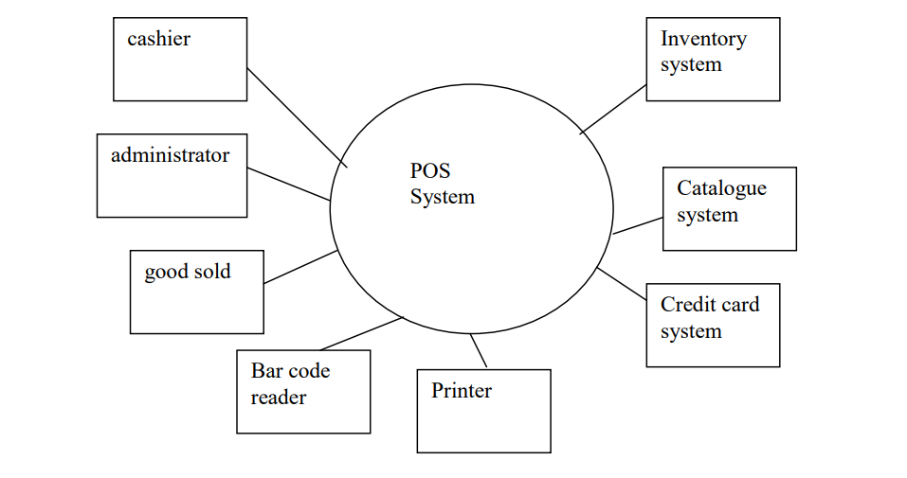

**Payroll Process DFD**



**PROPOSED SYSTEM**

CHAPTER # 3

* Objectives
* System Proposal
* Main System Diagram
* Benefits /Main Features of Proposed System

**OBJECTIVES OF THE PROPOSED SYSTEM**

#### 1. Strengthen a positive customer experience

According to Forbes**,** [79% of online shoppers](https://www.forbes.com/sites/nicoleleinbachreyhle/2016/04/20/customer-loyalty-in-todays-modern-retail-world/#4940faf03008) will turn to a competitor if they experience poor customer service in the first week. That’s a fast way to lose a customer, right?

At this stage, it’s not just about customer support, it’s also about the way you show your customers that you value them for making a purchase at your store. A loyalty program provides the perfect vehicle to do this. But how?

Let’s take a little detour into the field of social-psychology.

When customers see that they can collect points in exchange for purchases, their first thought is, “Wow, it’s so cool that I get something extra for my money besides the product I purchased!”

This positive experience also invokes a desire to ‘return the favors,’ motivating shoppers to purchase from you again. This social rule is called [**reciprocity**](https://www.entrepreneurs-journey.com/11221/reciprocity/) and you can watch this video of Robert Cialdini, a reciprocity expert, for more details on how this phenomenon plays out in the mind.

#### 2. Show customers that it’s worth it to come back to your store

Remember why your best friend collected stars at Starbucks? Because after every 12th purchase, they got a free drink or snack. (Although, if you’ve been following the news lately, then you may know that Starbucks actually changed their reward mechanism in early 2016.)

The point here is that customers are loyal because they want to **save money.** This is the traditional (spend-a-dollar and earn-a-point) loyalty program approach that appeals to a wide range of customer groups. But it’s not enough! Nowadays, [76% of shoppers](http://www.businessinsider.com/starbucks-rewards-makes-major-change-2016-4) expect some kind of recognition besides monetary benefits, like a **special treatment** perk that gives them a smoother, faster and more personalized shopping experience.

#### 3. Encourage customer referrals

Imagine this. You’re at a relaxed dinner party and your friend asks you which mobile phone you would recommend. You have just purchased the latest iPhone and you love it, so you list all of the phone’s greatest features to convince your friend to buy it as well. They go home and think it over, and sure enough, next week they order the very same iPhone.

Okay. Now let’s say that you want your customers to replicate this satisfied recommendation scene virtually. A loyalty program allows you to do this, at an exponential rate. How?

If your loyalty program rewards customers for referring their friends, they will be more than happy to spread the word about you. The most common tactic to use here is a [dual-sided reward mechanism](http://www.extole.com/blog/the-ultimate-guide-to-referral-marketing), where both the referrer and his referral benefit from the process.

#### 4. Build social proof

Forbes shared that [81% shoppers](https://www.forbes.com/forbes/welcome/#391fec3c40a5) research products, compare prices and read reviews before making their purchases. (I’m sure you do the same thing before buying your next laptop or coffee maker, running shoes or really anything!)

While a loyalty program improves customer satisfaction in your store, it also provides opportunities for you to remind and reward customers for leaving product reviews or using certain Instagram hashtags while posting photos about your products, to name just a few examples.

This is the land of user-generated content that increases trust towards your eCommerce store and even helps customers to make purchase decisions faster. Ambassador reported that [88% of customers trust online reviews](https://www.getambassador.com/blog/word-of-mouth-marketing-statistics), so it’s worth investing your effort into this field.

#### 5. Maximize brand advocacy

A **brand advocate** is someone who elevates your **brand** through word of mouth marketing. **Brand advocates** leave positive reviews about your product. They also refer new customers and create content on your behalf. **Brand advocates** even contribute useful insights to your user personas.

SYSTEM PROPOSAL

##### SUBJECT: SYSTEM PROPOSAL

Simplicity Loyalty is a powerful and platform that runs a diverse range loyalty and rewards programs for a range of customers from QSR Loyalty, Automotive Loyalty, Health Loyalty and a host of Retail Loyalty programs both large and small customers.

To meet the demands of such a diverse range of programs, Simplicity is designed as a platform as a service (PAAS). Extensible modules provide intuitive access to the platform for marketers, program administrators, customer service teams and partners. Web services and Loyalty APIs provide a data integration layer to simply seamlessly interact with POS systems, web sites, apps and other integrated systems

**SCOPE OF THE PROJECT**

## 

## **Earning and redeeming points**

With Simplicity Loyalty you can award points to your loyalty members, or design your own unique loyalty currency. You can award points based on transaction value and set minimum spend thresholds before points are awarded. Or you can set different reward rates for certain products, product categories or entire departments. You can define bonus rules that set a different reward rate for promotions and marketing campaigns – with complex eligibility rules.

Similarly, rewards are flexible and configurable. You can use vouchers, credits or discounts – or define unique rewards such as gifts or merchandise that your customers may value more highly.

#### Points or Dollars Earning

* Earn X points per Y spend variable by program and tier
* Bonus points on activity such as Welcome
* Set points earning based on member, program, tier, partner and offer
* Can be on Payment received or sale or both
* Items can be excluded such as specials, service classes, discounted products or entire departments
* Target spend Bonus points can be awarded based on spend over time based on multiple rules configured for any program or member providing many options for both lump sum bonus and points multiplier options
* Points can be charged to the Program or Partners or Outlets of Partners

#### Rewards

* Online Redemption store in Member Portal enabling member to redeem with Points or program currency or credit card or combination of all
* Redemption offers based on program and tier
* Cashback option on achieving targets
* Vouchers based on business rules
* Gifts based on business rules
* Merchandise
* Free or discount services by program and tier
* Exclusive benefits by program and tier
* Status levels and tiers

#### Recording transactions

* Scan loyalty card using existing POS system
* Scan card on a separate tablet
* Scan virtual card from smartphone API
* Integrate with payment processor so no card is required

## **Card or Cardless programs**

#### Virtual cards

Virtual cards encode the member ID into a smartphone app. During a transaction your customers then present the app to the POS operator for scanning, or scan it themselves using a self-service scanner or kiosk.

Simplicity can integrate with your existing app or supply a generic Simplicity Loyalty App customized for your program (optional cost). The Simplicity Loyalty App provides a convenient way for consumers to register for the program, maintain their details, review recent transactions and redeem. Virtual cards can be emailed to your member or simply reside in the app.

#### Cardless loyalty programs

With cordless loyalty programs we need an alternative identifier such email address, mobile phone number or payment card number. Your customer registers this ID when they enroll in the program, and supply it when completing a transaction.

#### Card based programs

Simplicity works equally well with traditional card-based programs. Store Cards preprinted with number barcode or QR code You can generate card numbers on the fly for card printing, and send them by post or offer them to customers at POS to maximize registrations.

#### Member portal and mobile app

* Simplicity Loyalty web Member Portal enables your customers to manage their membership details online, in-app or on-premise using a kiosk. All interfaces enable consumers to:
* Enroll in the loyalty program
* Activate existing store card
* Register cards
* Maintain member profile including phone numbers, email addresses, contact details and marketing opt-ins
* Create and manage Friends and Family shared points pool and invite people to join
* Review recent transactions
* Check points balance and tier status
* View vouchers
* Browse redemption portal of available rewards and offers
* Request replacement card
* Submit customer service enquiries
* Access terms and conditions, frequently asked questions
* Change password one-way encrypted bank level security

You can add your own branding to the standard templates in Simplicity Loyalty, or integrate an existing site using iframes or an intuitive Web Services API.

#### Contact center and customer service desk

Simplicity Loyalty also provides Contact Centre screens to help resolve calls and queries efficiently. Customer Service staff can quickly access all necessary details regarding recent transactions or any other interaction with your business such as a marketing email received, an online enquiry submitted or a competition entry lodged.

Every call or enquiry creates a case, which is tracked through to closure with all related Actions stored against that original case. Cases can be escalated and transferred as appropriate, with a case management dashboard summarizing the status of all open cases and statistics for average age and average time to resolution.

## **Direct Marketing**

Simplicity Loyalty provides native access to all loyalty data including transactions, preferences, demographic information, survey responses, help desk queries and much more.

More than just access to data, Simplicity makes data actionable. Use intuitive campaign management tools to create targeted, compelling marketing communications across email, SMS, social, Direct Mail and many other marketing channels.

#### Contact lists

* Your contacts are automatically available for campaigns – no data exports or integrations required

#### Standard Email and communications set up within the program

* Member welcome
* Admin welcome
* Partner Admin / POS portal welcome
* POS portal welcome
* Order confirmation
* New voucher issued
* Virtual card resend
* Invite friends and family to join shared points pool
* A new voucher has been issued after a voucher has expired
* Member reset password
* Member reset password confirmation
* Admin reset password
* Admin reset password confirmation
* Partner / POS reset password
* Partner / POS reset password confirmation

#### Advanced marketing

* Targeting and segmentation
* Local area marketing for Outlets and Stores
* Dynamic content including offers and vouchers
* Personalization
* A/B testing
* Device preview
* Social media integration
* Campaign reporting
* SPAM management
* Campaign Automation
* System operations and security such as signup, forgotten password and password reset

#### Campaign Portal

* Enable distributed teams to send and tailor email marketing for local audiences
* Pre-approved customer segments
* Restricted templates that control branding and standard undatable regions

#### Survey

* Rich quality surveys created by users
* can be added to signup process with incentive rewards for completion
* campaigns can be created to recipients and segmented based on answers

#### Program Financial Management

* Manage points pool
* Charging and payments of Partners for issuing and redeeming rewards and to partners for redemption of value based vouchers
* Tracking of all voucher usage for subsequent billing and reporting
* Bank files created for major banks and provided securely to your accounts team to process

#### Coupons and Vouchers

* Automatically generate vouchers at pre-determined points thresholds.
* Create an offer for redemption where each redeeming member is provided access to a single code.  This code can be automatically generated by Simplicity or entered when the offer is setup.  When the offer is purchased, the code is then available to the member on the web or on their App.
* Create an offer where on redemption, a new voucher is created for a set period of time and made available to the member on the web or on their App.
* Create an offer where on redemption, a new voucher is allocated to the member from an uploaded set of voucher codes.  This list can be supplied by a third party from their platform if they are not able to integrate with the Simplicity POS services in real time, so the codes can be loaded in their POS already.
* Create an offer where on redemption Simplicity contacts a third-party web service and requests a voucher from the offer code.  This is used when integrating with a voucher supply partner.  Once the third-party provides back the voucher details, the voucher is created and made available to the member on the web and in their App.
* All “Shopping cart vouchers” (vouchers purchasable via the redemption mall) can be setup such that a member must enter their password or authenticate in some way to reveal the voucher code.  When they do, the voucher is set to “Used”.  This functionality can be used for when your redemption partner is not able to integrate with the Simplicity web services to use vouchers in real time.

#### Partner referral

* Partners offers in the Redemption mall and personalized voucher downloaded to the member. Track this offer against the member as proof to the Partner of a referral and also pass to the partner the members Token, which is the same as the voucher number provided to the member, so that the Partner can track this lead. Also enable the partner to update the lead by way of web services to enable you to track sales opportunities and conversions for commission management.

## **A superior user experience**

Most retail loyalty programs require action from staff and customers at the POS. But no two programs are the same. Some require maximum throughput speed and minimum disruption to existing processes. Others can take the time to enroll new members at POS and investigate customer service queries. With multiple POS integration options, Simplicity Loyalty has a POS solution for every scenario.

#### Program Management

Admin and Partner Portals enable you to fully manage all aspects of your program, plus all the financial settlements that are required with a Franchisor Loyalty - Franchisee Loyalty program. Or for Retail Loyalty programs where Partners are remunerated from sales made using points or cash from within the redemption mall.

* Track the performance of your marketing strategy all the way to the bottom line. That means actual sales generated from coupons, vouchers and email marketing campaigns.
* Identify your top customers and top customer segments.
* Identify which products your highest value customer buy and which they never buy

#### Full Transaction Sync

* Real-time transaction loading from POS to Loyalty
* Periodic transaction export and synchronization

#### Performance at scale

* Designed for maximum speed and performance to achieve sub-second processing times for every transaction
* Optimized for fast real time performance at POS. For over 20 transactions per second and failover options additional services provided under additionally costed contract
* Resilient design to prevent outages and downtime

#### Web services API

* Create your own POS integrations using the fully featured web services API

#### POS integration

* Create your own POS integrations using the fully featured web services API
* Browser based POS for simple integration with no programming required
* Separate tablet-based POS for superior customer experience

#### Scanners and receipts

* Use any barcode format to work with your existing scanners, including QR codes
* Personalize receipts with offers, messages, loyalty balances and more

## **Franchise support**

Simplicity Loyalty provides numerous features and modules to support franchise networks and individual franchise owners. From stores level reports to localized marketing through to managing the financial implications of earning and burning points across multiple stores.

#### Financial

* Calculate points pool debits, credits and transfers due to redemption activity across the network
* Automatically credit expired points to the original store or head office
* Create end-of-period journal files for import into financial systems

## **Reports**

#### Program reports

* Card/Account Issued Report
* Segment Report
* Segment Monthly Summary Report
* Home Store Report
* Voucher Summary to Date
* Valid Vouchers Report
* Used / Redeemed Voucher Report
* Expired Voucher Report
* Campaign Pre/Post Transaction Report

#### Campaign reports

* Recent Campaign Activity
* Campaign Analysis Campaign Compare
* Campaign Analysis by Segment
* Campaign Analysis Summary
* Campaign Analysis
* Online Form Campaign Analysis
* Email Campaign Analysis
* Email Campaign Analysis by Campaign Execution

#### Campaign reports

* Daily Sales Report
* Bonus Points Register
* Transactions in Suspense Report
* Transaction Audit Report
* BCI Summary Report

MAIN SYSTEM DIAGRAM (PROPOSED)

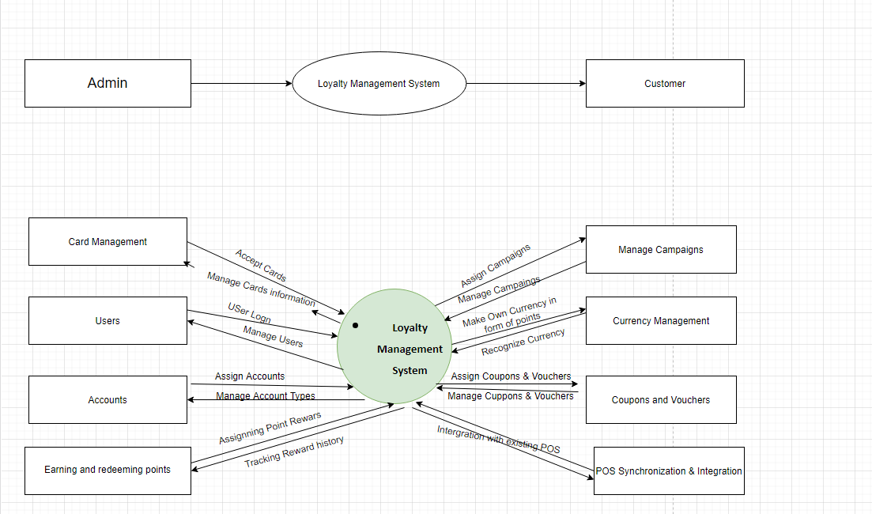

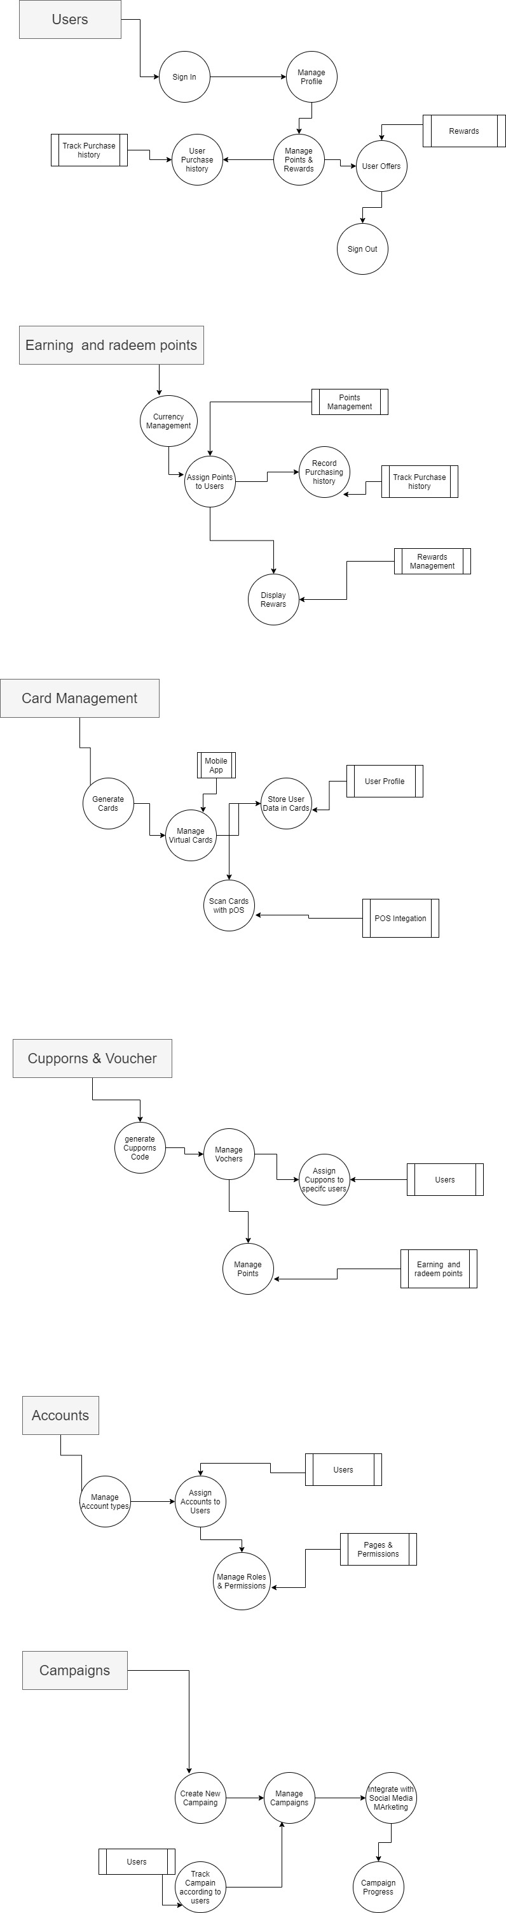

**BENEFITS/MAIN FEATURES OF THE PROPOSED SYSTEM**

* Increase customer satisfaction
* Create new loyalty programs as per your requirement
* Facility of managing loyalty programs
* View earned history of customer loyalty points
* Know the spent history of customer loyalty points
* View customer wise loyalty history
* Know about loyalty points in quotations and sales orders
* View loyalty rewards directly from shopping cart